Brent Knopp

Champion Document

**1.  Brief Introduction:**

My feature is titled Action Event. It will handle all aspects of a players turn after an individual unit has moved and an action is selected. Each player will have multiple units in a game, where one individual unit will be moved on the game board per each turn. After the unit is moved and an action is confirmed this feature will be invoked. The scope of the feature will consist of handling how a selected action event will affect the attributes of both units involved in the event. At most there will only be two units involved in an action event. The base game will consist of two action events: battle and do-nothing. The battle event is an attack on an enemy, while the do-nothing event is used as a defensive maneuver or to close distance before an attack can be performed. As the game expands in development, more action events can be added to the action event superclass. For example, we might include the option to buy or trade game items used in battle to increase a unit’s weapon attribute for battle.

The battle action event will mainly handle the unit’s attack with an emphasis on awarding the correct damage to each unit, per attack. It will include all animation graphics involved in the attack. The unit will first suffer damage from the type of terrain that the unit has moved to. Then, the attack will commence, and each unit will be allowed to do one damage sequence followed by an animated battle scene that will be displayed for the battle. The battle event will calculate the damage of each attack based on the unit’s experience attributes and weapon attributes used, followed by an update of the overall health of each unit involved in the attack. There will be experience points awarded from a successful battle attack that will make the unit’s attributes stronger for future attacks. Health will then be checked to decide if any of the involved units are dead and will then be immediately eliminated from the game with an animated death scene.

The end of this feature will coincide with the end of the player's turn. The do-nothing event is a basic event that will only check and update damage from terrain movement. There will be no battle in this type of action, but the unit must adhere to terrain damage with each move. The do-nothing event will check the health of the unit to see if it has died, followed by a death animation graphic. The form of action will be used as a defensive strategy or when a unit needs to cover a large amount of terrain before it can attack.

**2. Use Case Diagram with Scenario**

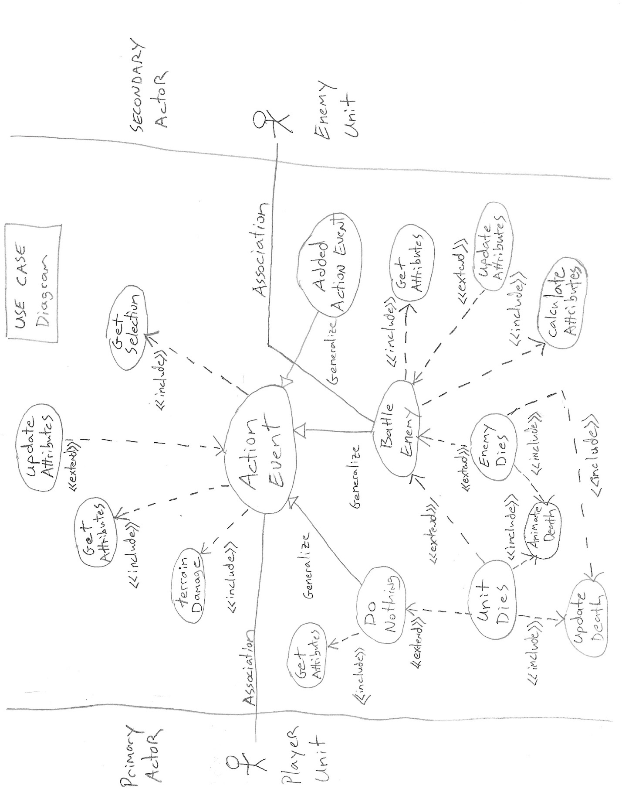

### Scenario

### Name: Action Event

**Summary:** The action event will handle the game play of a selected action per a player’s turn. This event will begin after the unit moves to a new position and a unit’s action is confirmed. The event will calculate and report how the involved unit’s attributes are affected for each event. It will report these changes and play the associated animated graphics involved in the event. The action event will finish after one event turn.

**Actor:** Player Unit

**Secondary Actor:** Enemy Unit

**Preconditions:** Player has selected a unit with an event choice.

**Basic sequence:**

**Step 1:** Deals damage to the player unit by the current terrain.

**Step 2:** Determine what action event is selected by the player unit.

**Step 3:** Determine which units’ attributes are involved in the event.

**Step 4:** Calculate the changes in the units’ attributes that occurred during the action event.

**Step 5:** Update the changes for the units’ attributes.

**Step 6:** Check for the units’ death.

**Step 7:** Animate the event sequence.

**Exceptions:**

**Step 1:** Invalid battle event selected.

**Step 2:** Invalid units selected for event.

**Post conditions:** Update attributes for units involved in the action event. The end of the feature is correlated with the end of the players turn.

**Priority:** Overall this feature is a priority 1* and must be included in the game, it is the backbone of the game play, which is how units’ attributes are affected by the game rules. However, we will only need two types of action events to get a base game running. The rest of the action events are a priority *3. Increasing the number of action events would make the game more interesting and increase the user’s attention. The animation of the battle scene is not needed and are of priority 3*.

**ID:** C01

*The priorities are 1 = must have, 2 = essential, 3 = nice to have.

**3. Data Flow diagram(s) from level 0 to process description for your feature**

**Level 0**

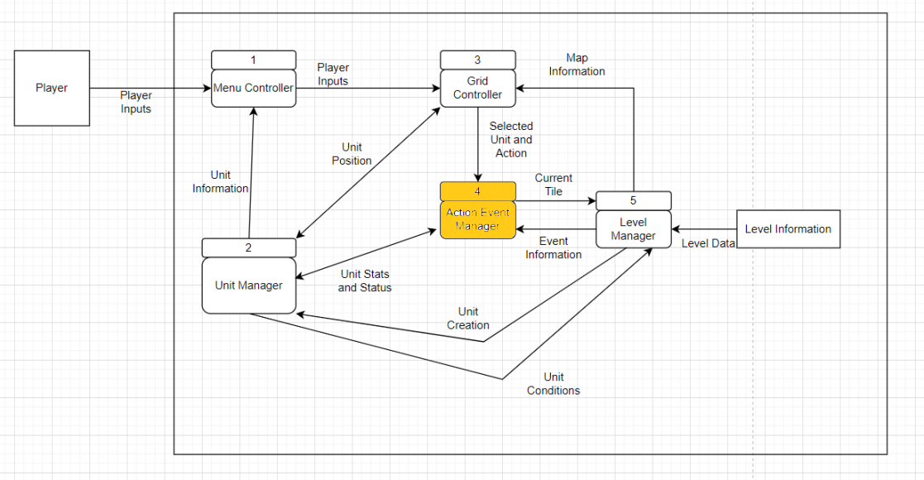

**Level 1**

### Process Description

***Event Manger 4.1*** process will control the flow of data between the system’s different features and the internal data structures in the action event feature. It must communicate with the features: Grid Controller, Unit Manager and Level Manager to request and transfer the correct data at the appropriate times. The event Manager will initiate the start and stop of the action event feature, initiate event calculation, initialize unit data structures, intialize data structure updates after an event and play event antimations.

***Event Calculator 4.2*** process will make all of the calculations for each event in which it will determine the effect on each unit’s properties that were involved. These changes will be updated to the internal data structure and be communicated to the unit manager feature. The data structures will be inputted into this process and outputted as an updated version back to the data structure. This process will be controlled by the event manager.

***Event Animation 4.3*** process will display the corresponding animation for each event. This process will be intiated and controlled by the event manager process.

***D1 unit info*** is the player unit and it’s attributes that will be involved in the event.

***D2 enemy info*** is the enemy unit and it’s attributes that will be involved in the event.

***D3 Terrain tile*** is the tile information that the event takes place on.

**4. Acceptance Test**

The inputs for this feature are the player’s action event selection, terrain tile that the player’s unit is positioned on, and the corresponding units’ attribute sets that are involved in action event. A typical “battle enemy” selection will involve both the player’s unit attributes and the enemy’s unit attributes. However, when “do-nothing” is selected it will only involve the player’s unit, since the enemy is not involved. The output of this feature is an updated units’ attribute set that will be changed directly by an event algorithm that is dependent on these four inputs: event decision, terrain tile, player’s attributes, and enemy’s attributes. This algorithm will update the health, weapon and experience attributes set based on a randomized battle algorithm giving preference to the unit with higher attributes. Thus, it will be responsible for determining when units are eliminated and destroyed from the game. The acceptance test for this feature will be a test that confirms that the proper units’ attribute calculations were done correctly, and the correct values were updated in the game resulting in the correct game piece being destroyed.

A baseline acceptance test would consist of creating randomized test vectors, which will include one player’s attributes, one enemy’s unit attributes, one type of event selection, and one type of terrain tile. The test will need to check all the damage calculations, check all experience calculations, and determine all deaths correctly happen to both units within each event. The tests will need to be done with all variations of health and check invalid instances with negative health or attack abilities. Every battle conclusion needs to be confirmed that the correct animation has occurred, game control has transferred to the enemy and only one battle event can be performed per turn. The do-nothing action will need to be tested to confirm that no enemy attributes are affected with this selection and the terrain damage is included in the event.

**5. Timeline**

|  |  |  |  |  |
| --- | --- | --- | --- | --- |
| **Work Items** | |  |  |  |
|  |  |  |  |  |
|  | **Task** | **Duration (per hrs)** | **Predecessor Task(s)** |  |
|  | 1. Feature Requirements | 5 | --- |  |
|  | 2. Create Event Interface | 8 | 1 |  |
|  | 3. Design attribute structure | 5 | 2 |  |
|  | 4. Logic for Battles | 7 | 2 |  |
|  | 5. Update Results of Event | 7 | 3, 4 |  |
|  | 6. Game Graphics of Battle | 10 | 1 |  |
|  | 7. Feature Testing | 7 | 5, 6 |  |
|  | 8. Installation of feature to Game | 4 | 7 |  |

**Pert Chart**

|  |  |  |  |  |  |  |  |  |  |  |  |  |  |  |  |  |  |  |  |  |  |  |  |  |  |  |  |  |  |  |
| --- | --- | --- | --- | --- | --- | --- | --- | --- | --- | --- | --- | --- | --- | --- | --- | --- | --- | --- | --- | --- | --- | --- | --- | --- | --- | --- | --- | --- | --- | --- |
|  |  |  |  |  |  |  |  |  |  |  |  |  |  |  | |  |  | |  | |  | |  |  | |  | |  |  | |
|  |  |  |  |  |  |  |  |  |  |  |  |  |  |  | |  |  | |  | |  | |  |  | |  | |  |  | |
|  |  |  |  |  |  |  |  | 13 | 5 | 18 |  |  |  |  | |  |  | |  | |  | |  |  | |  | |  |  | |
|  |  |  |  |  |  |  |  | 3 | | |  |  |  |  | |  |  | |  | |  | |  |  | |  | |  |  | |
|  |  |  |  |  |  |  |  | 15 | 2 | 20 |  |  |  |  | |  |  | |  | |  | |  |  | |  | |  |  | |
|  |  |  |  | 5 | 8 | 13 |  |  |  |  |  | 20 | 7 | 27 | |  |  | |  | |  | |  |  | |  | |  |  | |
|  |  |  |  | 2 | | |  |  |  |  |  | 5 | | |  | |  |  | |  | |  | |  |  | |  | |  |
|  |  |  |  | 5 | 0 | 13 |  |  |  |  |  | 20 | 0 | 27 | |  |  | |  | |  | |  |  | |  | |  |  | |
|  |  |  |  |  |  |  |  | 13 | 7 | 20 |  |  |  |  | |  |  | |  | |  | |  |  | |  | |  |  | |
|  |  |  |  |  |  |  |  | 4 | | |  |  |  |  | |  |  | |  | |  | |  |  | |  | |  |  | |
| 0 | 5 | 5 |  |  |  |  |  | 13 | 0 | 20 |  |  |  |  | |  | 27 | | 7 | | 34 | |  | 34 | | 4 | | 38 |  | |
| 1 | | |  |  |  |  |  |  |  |  |  |  |  |  | |  | 7 | | | | | |  | 8 | | | | |  | |
| 0 | 0 | 5 |  |  |  |  |  |  |  |  |  |  |  |  | |  | 27 | | 0 | | 34 | |  | 34 | | 0 | | 38 |  | |
|  |  |  |  |  |  |  |  |  |  |  |  |  |  |  | |  |  | |  | |  | |  |  | |  | |  |  | |
|  |  |  |  |  |  |  |  |  |  |  |  |  |  |  | |  |  | |  | |  | |  |  | |  | |  |  | |
|  |  |  |  | 5 | 10 | 15 |  |  |  |  |  |  |  |  | |  |  | |  | |  | |  |  | |  | |  |  | |
|  |  |  |  | 6 | | |  |  |  |  |  |  |  |  | |  |  | |  | |  | |  |  | |  | |  |  | |
|  |  |  |  | 15 | 12 | 27 |  |  |  |  |  |  |  |  | |  |  | |  | |  | |  |  | |  | |  |  | |
|  |  |  |  |  |  |  |  |  |  |  |  |  |  |  | |  |  | |  | |  | |  |  | |  | |  |  | |
|  |  |  |  |  |  |  |  |  |  |  |  |  |  |  | |  |  | |  | |  | |  |  | |  | |  |  | |

**Gantt Chart**

|  |  |  |  |  |  |  |  |  |  |  |  |  |  |  |  |  |  |  |  |  |  |  |  |  |  |  |  |  |  |  |  |  |  |  |  |  |  |  |
| --- | --- | --- | --- | --- | --- | --- | --- | --- | --- | --- | --- | --- | --- | --- | --- | --- | --- | --- | --- | --- | --- | --- | --- | --- | --- | --- | --- | --- | --- | --- | --- | --- | --- | --- | --- | --- | --- | --- |
| **TASK** | 1 | 2 | 3 | 4 | 5 | 6 | 7 | 8 | 9 | 10 | 11 | 12 | 13 | 14 | 15 | 16 | 17 | 18 | 19 | 20 | 21 | 22 | 23 | 24 | 25 | 26 | 27 | 28 | 29 | 30 | 31 | 32 | 33 | 34 | 35 | 36 | 37 | 38 |
| **1** |  |  |  |  |  |  |  |  |  |  |  |  |  |  |  |  |  |  |  |  |  |  |  |  |  |  |  |  |  |  |  |  |  |  |  |  |  |  |
| **2** |  |  |  |  |  | 1 |  |  |  |  |  |  |  |  |  |  |  |  |  |  |  |  |  |  |  |  |  |  |  |  |  |  |  |  |  |  |  |  |
| **3** |  |  |  |  |  |  |  |  |  |  |  |  |  | 2 |  |  |  |  |  |  |  |  |  |  |  |  |  |  |  |  |  |  |  |  |  |  |  |  |
| **4** |  |  |  |  |  |  |  |  |  |  |  |  |  | 2 |  |  |  |  |  |  |  |  |  |  |  |  |  |  |  |  |  |  |  |  |  |  |  |  |
| **5** |  |  |  |  |  |  |  |  |  |  |  |  |  |  |  |  |  |  |  |  | 3,4 |  |  |  |  |  |  |  |  |  |  |  |  |  |  |  |  |  |
| **6** |  |  |  |  |  | 1 |  |  |  |  |  |  |  |  |  |  |  |  |  |  |  |  |  |  |  |  |  |  |  |  |  |  |  |  |  |  |  |  |
| **7** |  |  |  |  |  |  |  |  |  |  |  |  |  |  |  |  |  |  |  |  |  |  |  |  |  |  |  | 5,6 |  |  |  |  |  |  |  |  |  |  |
| **8** |  |  |  |  |  |  |  |  |  |  |  |  |  |  |  |  |  |  |  |  |  |  |  |  |  |  |  |  |  |  |  |  |  |  | 7 |  |  |  |